**学术报告**

**Developments in Automotive Power Electronics andthe Outlook for SiC Semiconductors**

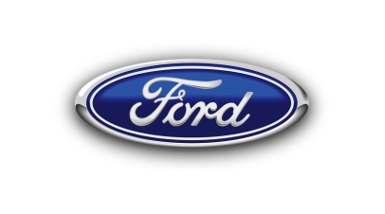**报告人:Dr. Michael W. Degner**Ford Motor

**报告地点:玉泉校区电机工程楼201会议室**

**报告时间:2017年2月23日上午10:00**

**报告摘要:**

The automotive industry is going through one of the largest transformations in its history. The simultaneous need for reducing CO2 emissions and the drive for new mobility solutions, including autonomous vehicles, is causing dramatic changes in the way vehicles are engineered and how our customers will use them. Power electronics are one of the enablers for both CO2 reduction and new mobility solutions through vehicle electrification.  The continuous push for reduced size, weight and cost of power electronic systems for use in these vehicle applications is causing a dramatic change in the way power electronic components and systems are engineered and integrated together. This talk will start by reviewing some of these changes in power electronic systems and components driven by their application in automobiles, including a brief overview of where this evolution may be heading.  The second portion will then focus on the opportunities created by SiC semiconductors and the challenges that they must overcome to achieve widespread adoption in automotive applications.

**个人简介：**

Michael W. Degner received the B.S., M.S., and Ph.D. degrees in mechanical engineering from the University of Wisconsin, Madison, in 1991, 1993, and 1998, respectively, with a focus on electric machines, power electronics, and control systems. In 1998, he joined the Ford Motor Company in Dearborn, MI, working in their Research and Advanced Engineering organization on the automotive application of electric machines and power electronics. He is currently the Senior Technical Leader of Electric Machine Drives and Manager of the Electric Machine Drive Systems Department of the Powertrain Research Laboratory, responsible for the global research and advanced engineering of electric machines, power electronics, and their control systems for hybrid, battery electric, and fuel cell vehicle applications. Dr. Degner has been granted more than 100 U.S. patents and has published more than 50 conference and refereed journal articles. He has also been the recipient of several IEEE Industry Applications Society Transactions and Conference paper awards.