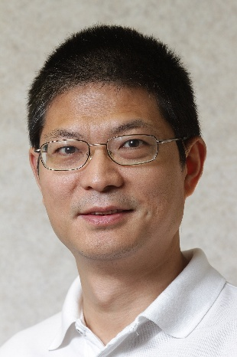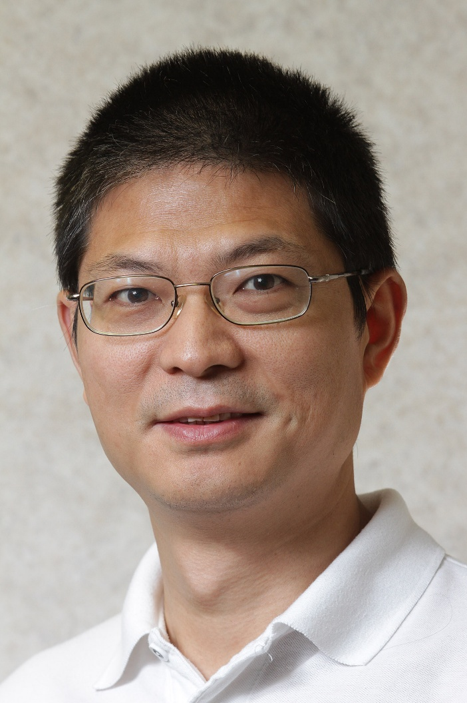

讲座通知

**High Efficiency Wireless EV Charging Using Wireless Power Transfer**

时间：2月24日（周五）

地点：电机工程楼201

主讲人:Chris Mi, Ph.D, Fellow IEEE

Professor and Chair, Department of Electrical and Computer Engineering

Director, GATE Center for Electric Drive Transportation

San Diego State University

San Diego, California, USAmi@ieee.org

**Abstract:**This first part of the presentation focuses on wireless power transfer technology that offers significant improvement in convenience and electric safety for EV and PHEVcharging. Our research aims at novel designs that considerably reduce size and cost while increase coupling coefficient and system efficiency. Distributed capacitors instead of lumped components is proposed. A double sided LCC resonant converter topology for the resonant stage is adopted to further enhance system efficiency. Laboratory prototypes have been built and 22kW power transfer has been achieved over 200mm distance,93.5% system efficiency (97% DC-DC efficiency), and alignment tolerance of up to 300mm.

The second part of the presentation discuss capacitive power transfer (CPT) for EV charging applications. It has been an established myth that good efficiency and stability of control was only possible in capacitive power transfer (CPT) at low power levels (in the tens of watts) and with low transfer distances (in the millimeter range). Dr. Chris Mi and his team have shown that it is possible to achieve excellent efficiencies at the power level and distance applicable to EV charging, breaking the established myth, enabling a paradigm change on EV charging, and making low cost wireless power transfer from science fiction to reality. A double-sided LCLC-compensated topology and its design process are proposed. A 2.4kW CPT system is designed with four 610mm × 610mm copper plates and an air gap distance of 150mm. The experimental prototype reaches a dc-dc efficiency of 90.8% at 2.4kW output power. At 300mm misalignment case, the output power drops to 2.1kW with 90.7% efficiency. With a 300mm air gap distance, the output power drops to 1.6kW with 89.1% efficiency.

**Brief Bio of Prof. Mi**:**Chris Mi** is a fellow of IEEE, Professor and Chair of the Department of Electrical and Computer Engineering, and the Director of the US DOE funded GATE Center for Electric Drive Transportation at San Diego State University, San Diego, California, USA. He was previously a professor at the University of Michigan, Dearborn from 2001 to 2015. He received the B.S. and M.S. degrees from Northwestern Polytechnical University, Xi’an, China, and the Ph.D. degree from the University of Toronto, Toronto, Canada, all in electrical engineering. Previously he was an Electrical Engineer with General Electric Canada Inc. He was the President and the Chief Technical Officer of 1Power Solutions, Inc. from 2008 to 2011. He is the Co-Founder of Gannon Motors and Controls LLC and Mia Motors, Inc.

His research interests are in electric and hybrid vehicles. He has taught tutorials and seminars on the subject of HEVs/PHEVs for the Society of Automotive Engineers (SAE), the IEEE, workshops sponsored by the National Science Foundation (NSF), and the National Society of Professional Engineers. He has delivered courses to major automotive OEMs and suppliers, including GM, Ford, Chrysler, Honda, Hyundai, Tyco Electronics, A&D Technology, Johnson Controls, Quantum Technology, Delphi, and the European Ph.D School. He has offered tutorials in many countries, including the U.S., China, Korea, Singapore, Italy, France, and Mexico. He has published more than 100 articles and delivered 30 invited talks and keynote speeches. He has also served as a panelist in major IEEE and SAE conferences.