**Title1:** Advanced device concepts – comparing SiC and GaN versus latest silicon technologies

**主讲人：**Braham Ferreira英飞凌电源管理及多元化市场首席科学家Gerald Deboy博士

时间：2017年4月21日（周五）15:00 - 16:00

地点：浙江大学玉泉校区　电机工程楼201室



Dr. Gerald Deboy received the M.S. and Ph.D. degree in physics from the Technical University Munich. His research interests were focused on the development of new device concepts for power electronics, especially the revolutionary COOLMOS(TM) technology. He is a Sr. member of IEEE and has served as a member of the Technical Committee for Power Devices and Integrated Circuits within the Electron Device Society. He has authored and coauthored more than 70 papers in national and international journals including contributions to three student text books. He holds more than 60 granted international patents and has more applications pending.

现场幸运大抽奖，丰厚礼品等你来拿!

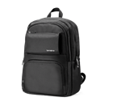

电脑双肩包

记事本

专业书籍：Fundamentals of Power Semiconductors for Automotive Applications

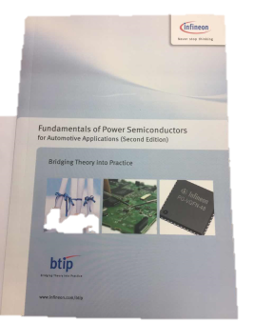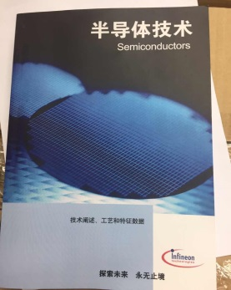

专业书籍：半导体技术